Criterion C

Development

Contents

Program Structure 4

Packages 4

Object-Oriented Programming 5

Encapsulation 6

Aggregation 6

Method Overloading 7

Error Handling 8

Using Try/Catch 8

User Input Validation 9

Registration/Login 9

Company Addition 9

Use of Files 11

Authentication 11

User 12

Creating User File 12

Retrieving User’s Companies 12

Company 13

Structure 13

Retrieving Company Data 14

Retrieving Statistic Data 16

Functionality 18

Company Merging 18

Company Valuation 21

Data Extrapolation 21

Final Calculation 24

Interfaces 25

Libraries 25

Java 25

JChart 25

References 25

# Program Structure

## Packages

The program is organized into packages for easier maintainability, the main packages being: “model”, “resources,” and “view.”

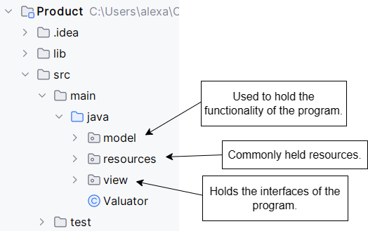

Figure 1 Program structure.

# Object-Oriented Programming

Object-Oriented Programming (OOP)[1] is a method of programming that takes problems, such as simulating real world entities such as, in my use cases, companies and users, and breaks them down into smaller tasks and representations using code[2]. I hate utilized OOP in my program to model the relationship more easily between users and companies, and companies and their data.

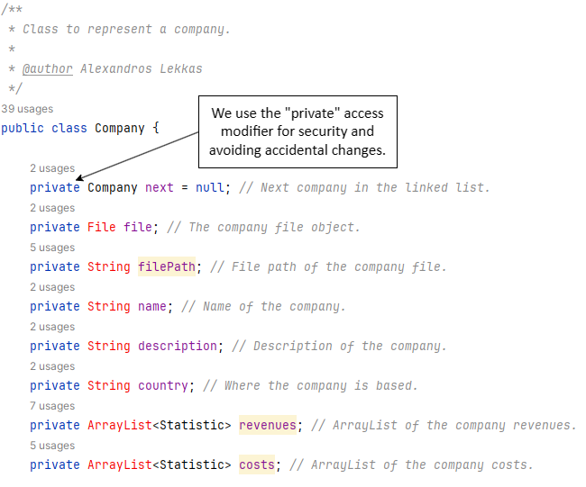

Figure 2 Object-Oriented Programming code.

## Encapsulation

Encapsulation[3] refers to the building of data with the mechanisms that operate the data. This means advanced data security, meaning that we can define how different classes or users of the program are allowed to access certain pieces of data.

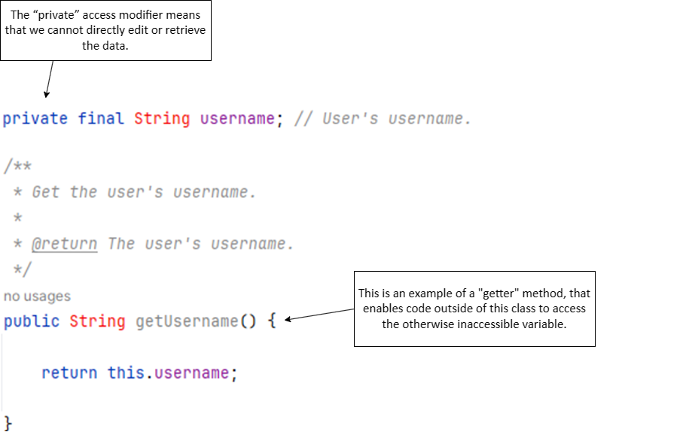

Figure 3 Encapsulation code.

## Aggregation

To represent the complex relationships contained in my program, I used aggregation[4], where one class has a ‘has’ relationship with another. What this means is that one class contains an object of another class.

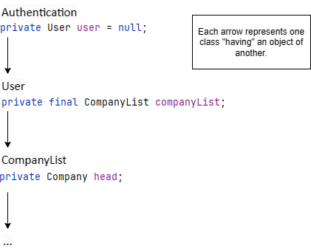

Figure 4 Aggregation code.

## Method Overloading

Method overloading[5] is a feature in Java is a feature allowing for a class to have more than one method with the same name but with different attributes. In my program, I used this for creating a Company object in different scenarios.

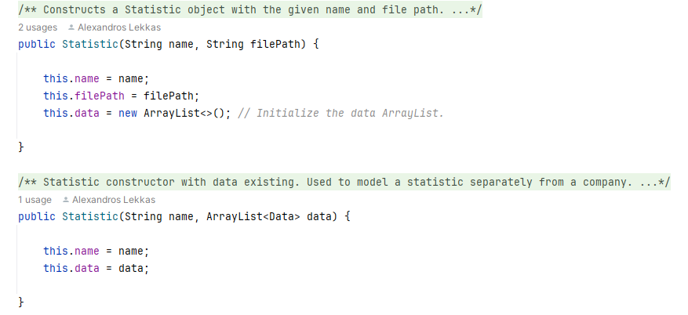

Figure 5 Polymorphism code.

# Error Handling

## Using Try/Catch

Try/Catch is a convenient functionality of Java[6], where if there is an error during the running of the program, if the “catch” implementation is there, the program will not fail[7]. Instead, we can create a way for the program to respond to the error.

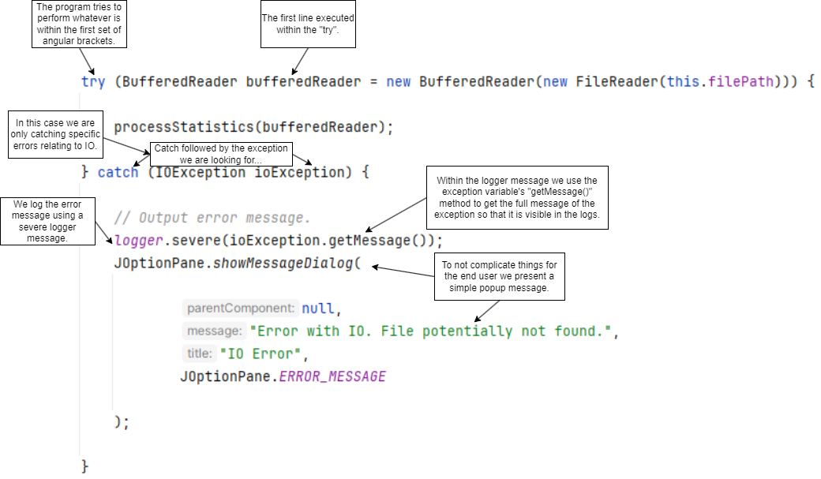

Figure 6 Try/catch error handling.

# User Input Validation

## Registration/Login

During login and registration, the user inputs their username and password, we validate if they are blank or equal to the placeholder text using if statements.

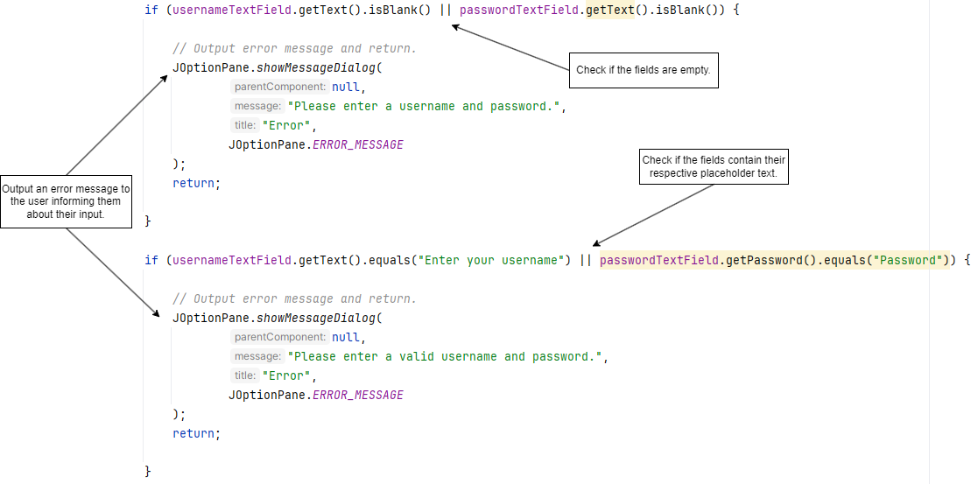

Figure 7 Registration/login input validation.

## Company Addition

When adding a Company from a file, the file selected by the user is checked to see if it is a CSV file[8].

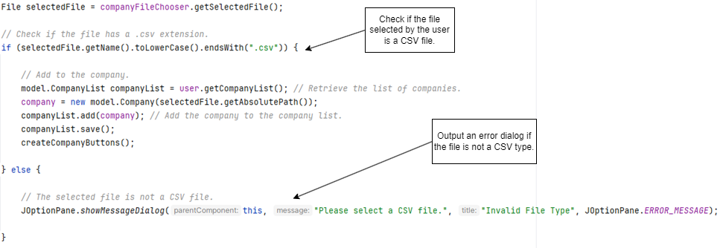

Figure 8 Company file checking.

# Use of Files

## Authentication

For storing the data of authenticated users, I implemented a RandomAccessFile[9]. A random-access file is a file which “behaves like a large array of bytes stored in a file system.” I used this file for my user authentication system. I use the Random-Access File because it is easy to create it when the program is run, and it has improved efficiency in CRUD operations[10]. In this file, I store data in an expected structure of a string paired with another string to represent the username and password.

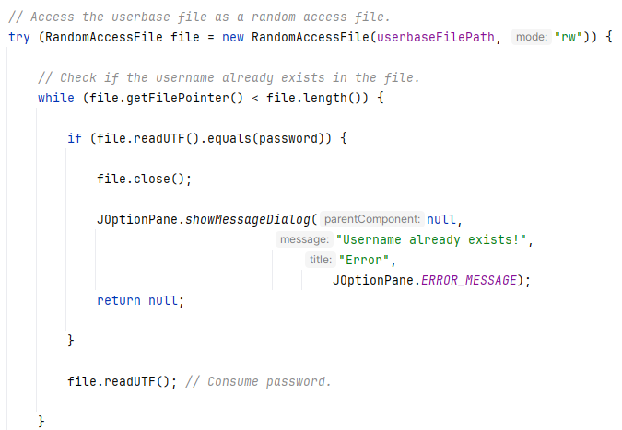

Figure 9 RandomAccessFile code.

## User

### Creating User File

When a new user creates an account, we create a new CSV file to hold which companies belong to them—named after their username.

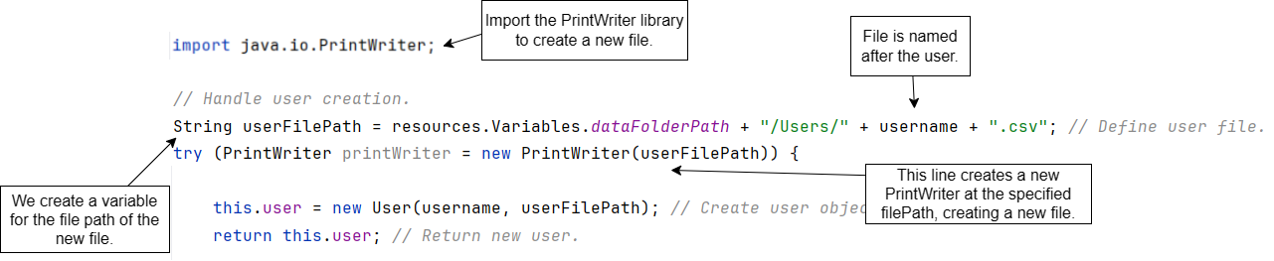

Figure 10 Creating user file.

### Retrieving User’s Companies

To be able to generate the dashboard interface with the correct companies belonging to the user showing the program must first load the company files the user has.

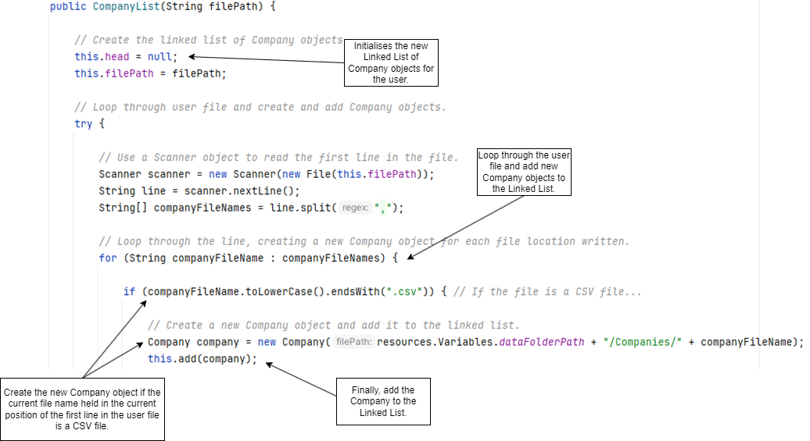

Figure 11 Retrieving companies for the user.

## Company

Each company has their data stored in a CSV file, a text file format that uses commas to separate values[11]. Acting somewhat as a table, this file is useful as it can be opened and modified in programs like Microsoft Excel[12], a program used frequently by the client, hence, why the file format was chosen.

### Structure

The file was broken into two sections using headers, details, and statistics. The details section holds basic information about the company (such as its name, description, and country), while the statistics section holds different revenues and costs as well as the associated data with each.

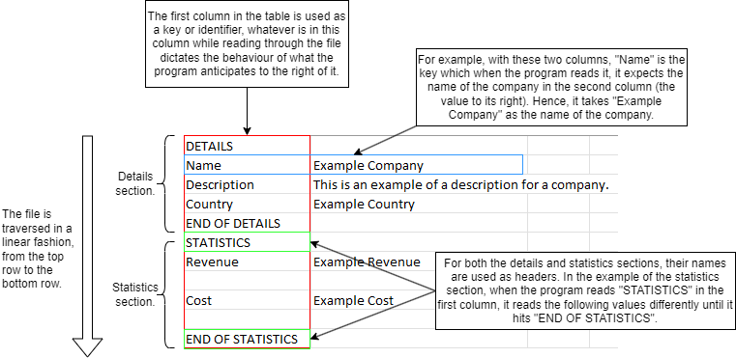

Figure 12 Company CSV file structure.

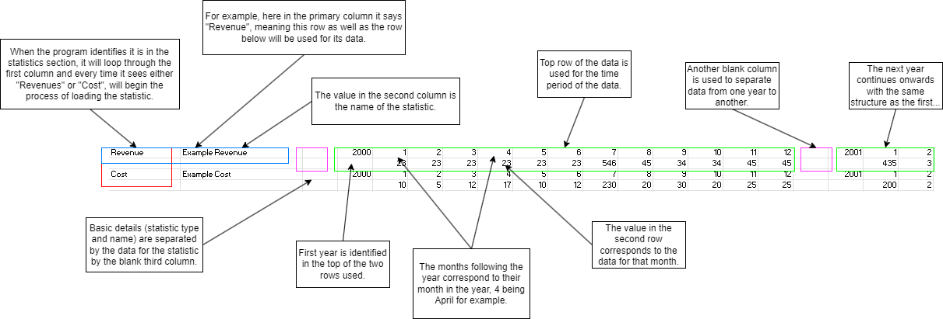

Figure 13 Statistic section and data structure.

### Retrieving Company Data

The use of CSV files for storing dynamic company data leads to complicated file loading and sorting. When checking for the data of a company the program looks for specific headers within the file, such as “DETAILS” and “STATISTICS”.

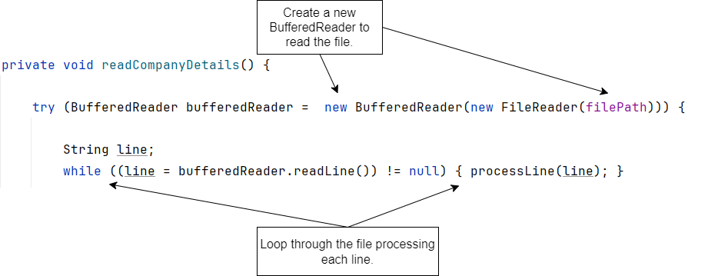

Figure 14 Reading company details method code.

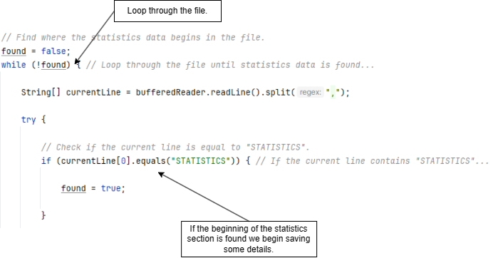

Figure 15 Checking for the statistics header code.

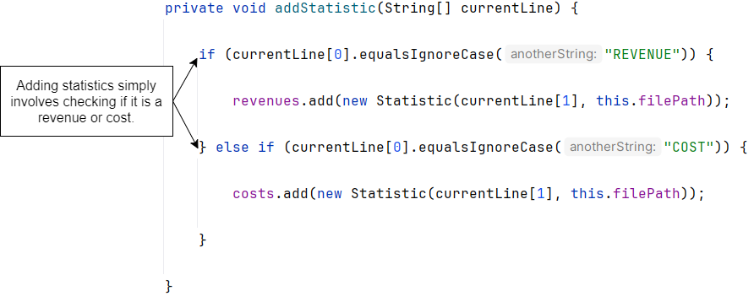

Figure 16 Adding statistics from file.

### Retrieving Statistic Data

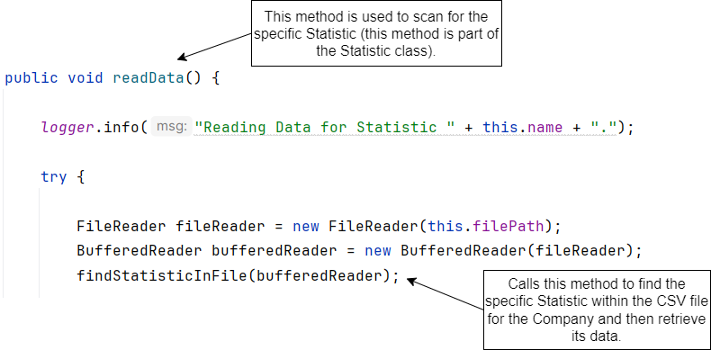

Figure 17 Starting to read Statistic data code.

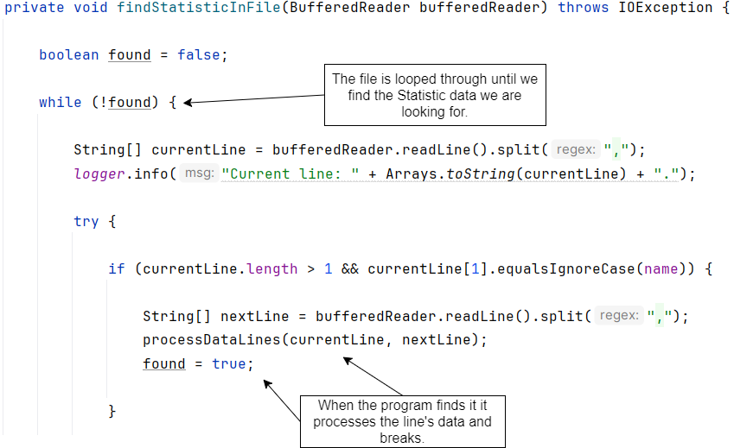

Figure 18 Searching for Statistic data code.

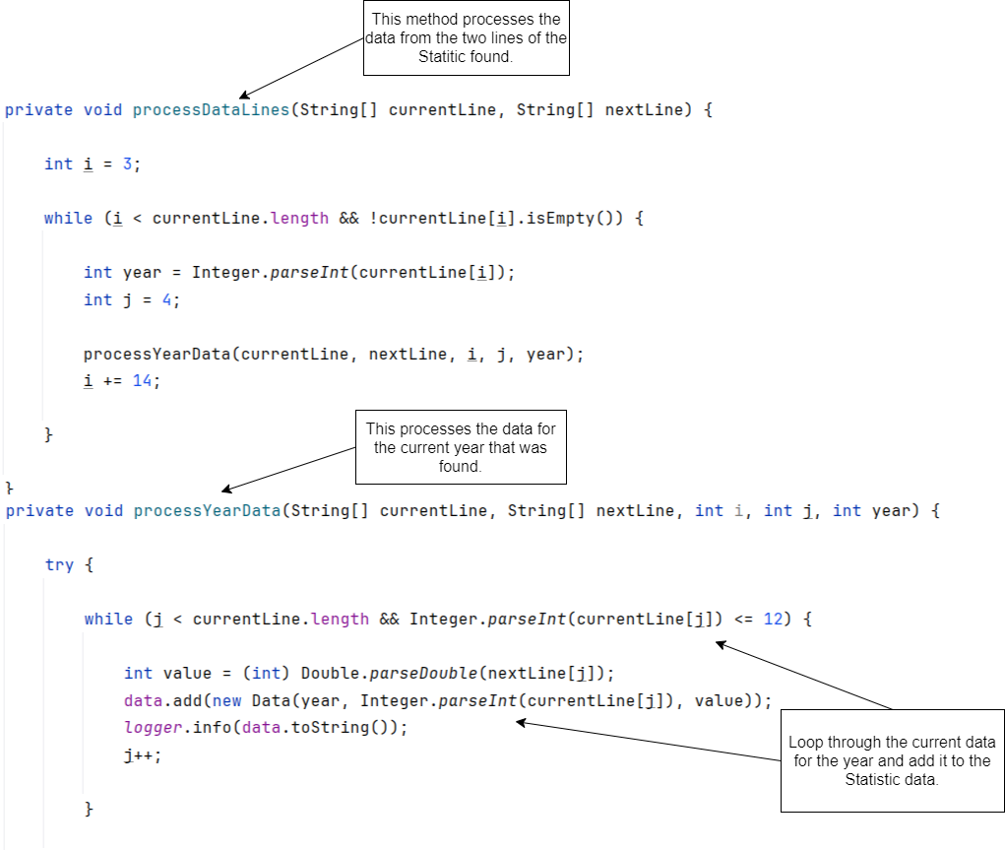

Figure 19 Adding Statistic data code.

# Functionality

## Company Merging

Techniques Used: ArrayList of Objects[13], For Each Loop[14] & Comperator[15]

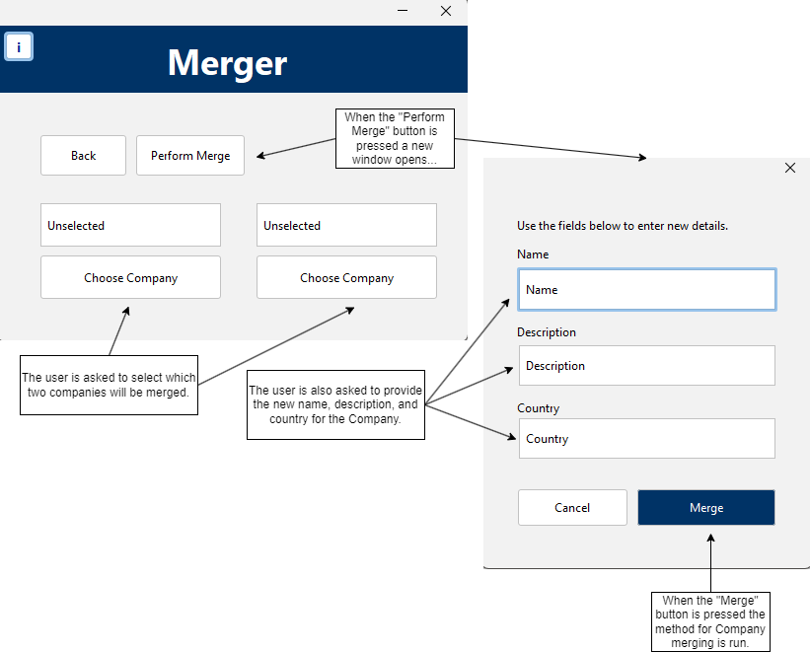

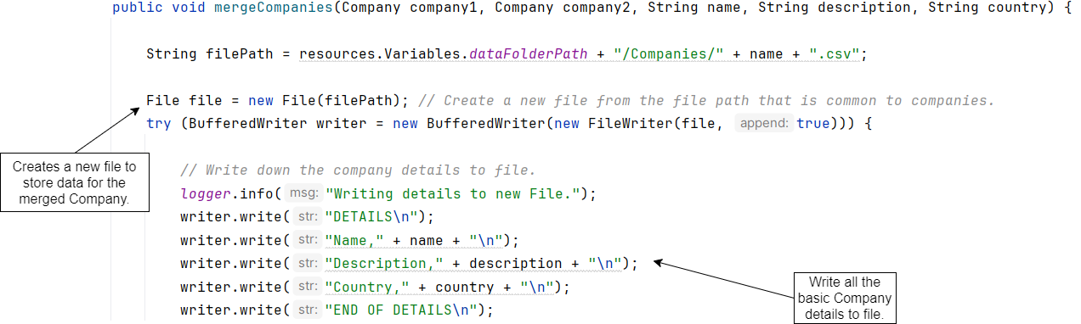

Figure 20 Merge companies method code snippet.

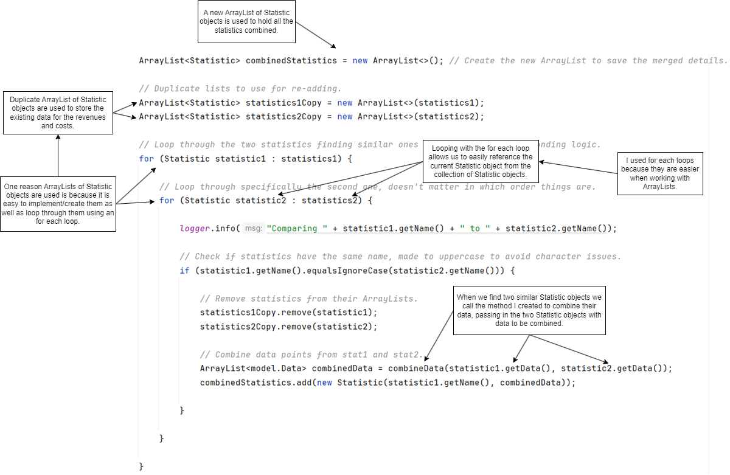

Figure 21 Combination of statistics code snippet.

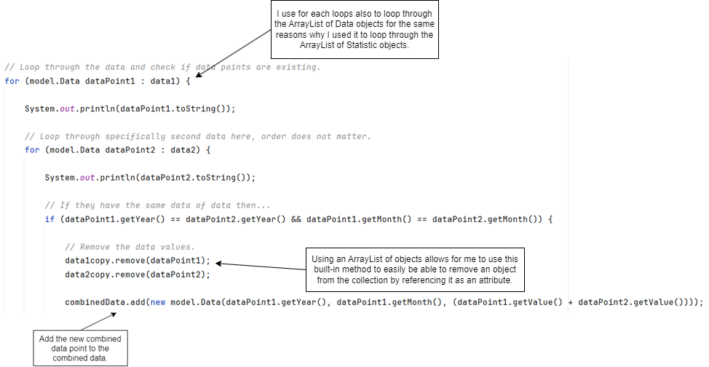

Figure 22 Combination of data code snippet.

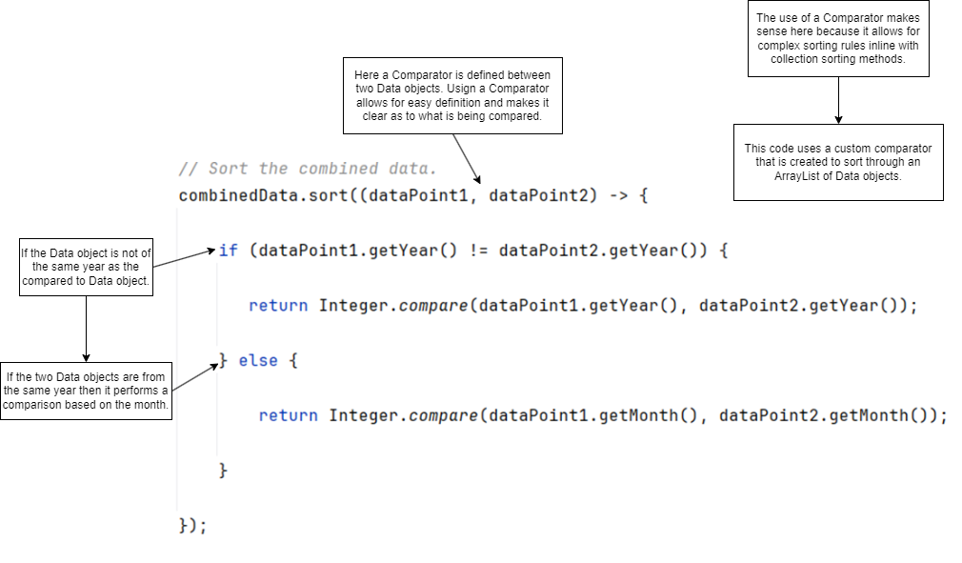

Figure 23 Sorting of combined Data objects using a Comparator code snippet.

## Company Valuation

Techniques Used: ArrayList of Objects, For Each Loop, For Loop[16]

### Data Extrapolation

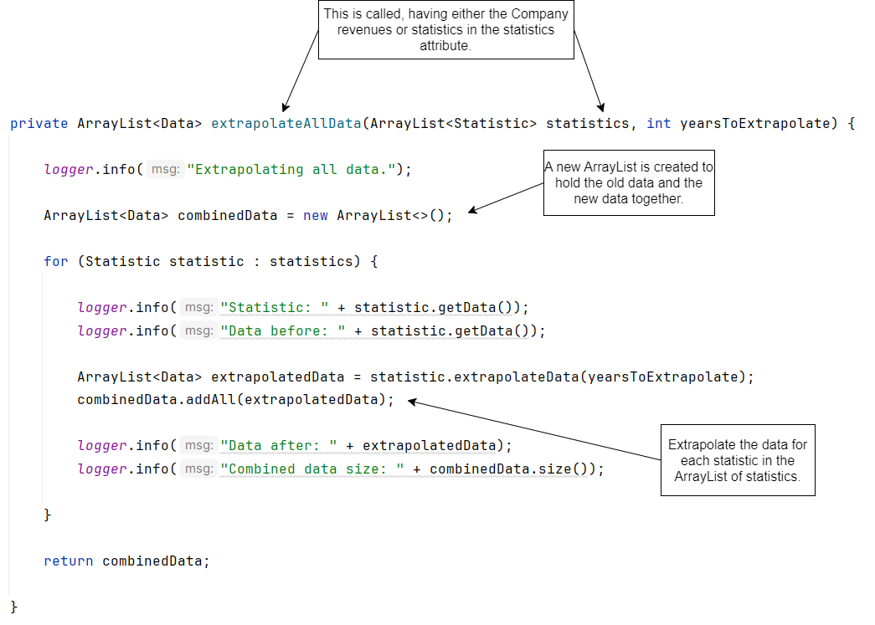

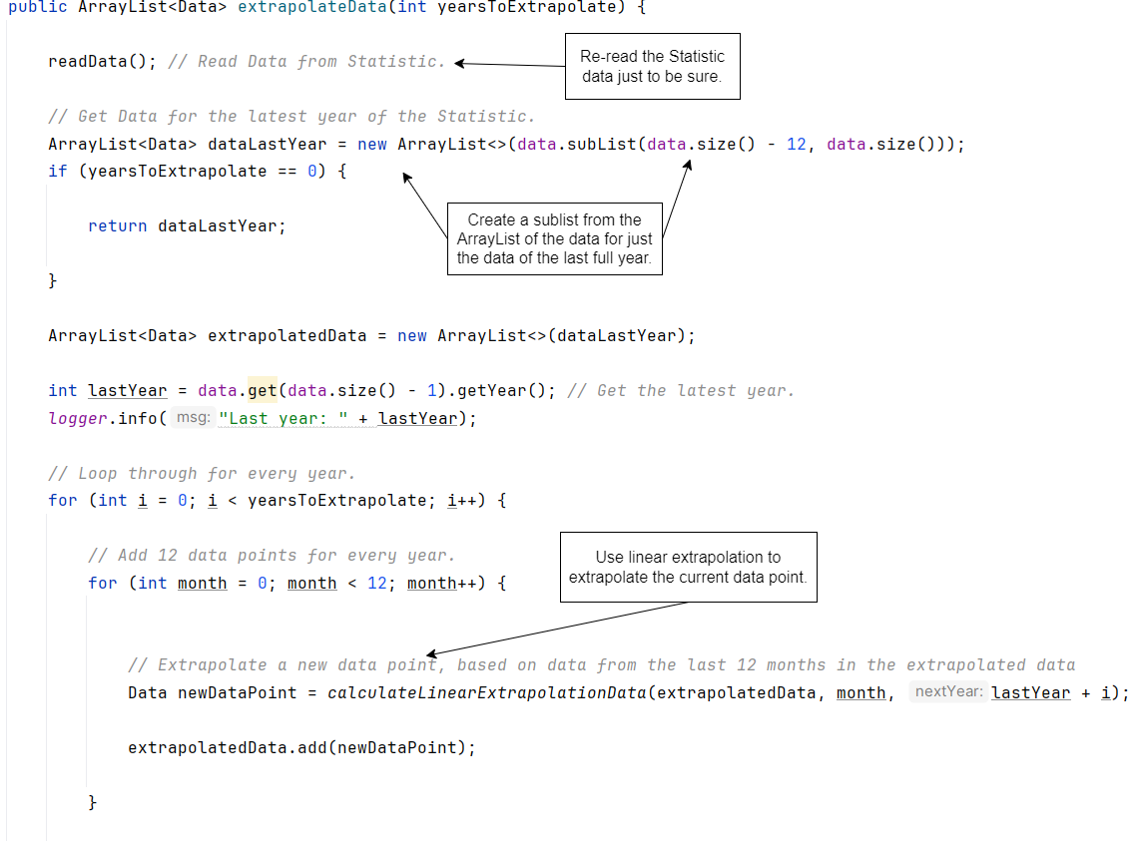

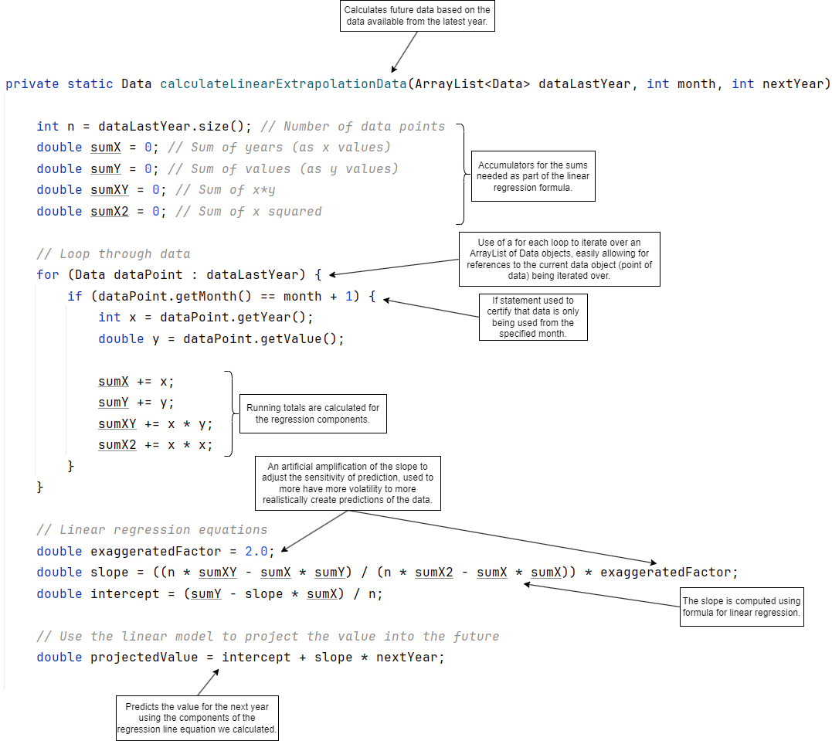

Figure 24 Extrapolation of data points using linear regression calculations code snippet.

### Final Calculation

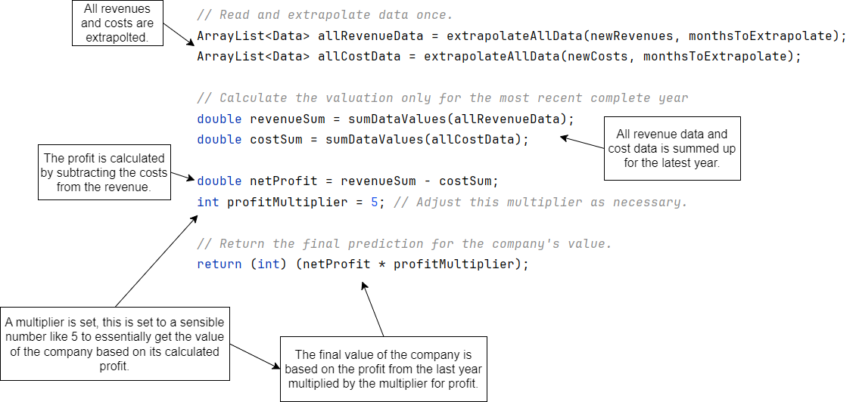

# Interfaces

Explanation netbeans generated code

# Libraries

## Java

|  |  |  |
| --- | --- | --- |
| Java.util.ArrayList | This is used to create ArrayList of objects | {url} |
|  |  |  |
|  |  |  |

## JChart

# References

*Aggregation in Java*. (n.d.). Retrieved from Javatpoint: https://www.javatpoint.com/aggregation-in-java

*Comma Separated Values (CSV) Standard File Format*. (n.d.). Retrieved 2 27, 2024, from Edoceo, Inc: http://edoceo.com/utilitas/csv-file-format

Debnath, M. (2021, March 25). *Random File Access Using Java*. Retrieved from Developer.com: https://www.developer.com/database/random-file-access-using-java/

GeeksforGeeks. (2023, February 16). *For-each loop in Java*. Retrieved from GeeksforGeeks: https://www.geeksforgeeks.org/for-each-loop-in-java/

Gillis, A. S. (n.d.). *TechTarget*. (S. Lewis, Editor) Retrieved from What is object-oriented programming?: https://www.techtarget.com/searchapparchitecture/definition/object-oriented-programming-OOP

*Java Exceptions - Try...Catch*. (n.d.). Retrieved from W3schools: https://www.w3schools.com/java/java_try_catch.asp

*Java Method Overloading*. (n.d.). Retrieved from W3schools: https://www.w3schools.com/java/java_methods_overloading.asp

Lawrence University. (n.d.). *Working with ArrayLists*. Retrieved from Lawrence: https://www2.lawrence.edu/fast/GREGGJ/CMSC150/062ArrayLists/ArrayLists.html#:~:text=What%20is%20an%20ArrayList%3F,a%20size%20for%20the%20array.

Liang, Y. D. (2017). Object Oriented Thinking. In Y. D. Liang, *Introduction to Java Programming, Brief Version, Eleventh Edition, Global Edition* (pp. 390-407). Pearson.

Microsoft. (n.d.). *Free online spreadsheet software: Excel: Microsoft 365*. Retrieved from Free Online Spreadsheet Software: Excel | Microsoft 365: https://www.microsoft.com/en-us/microsoft-365/excel

Oracle. (2024, January 8). *Comparator (java platform SE 8 )*. Retrieved from Oracle: https://docs.oracle.com/javase/8/docs/api/java/util/Comparator.html

Oracle. (2024, January 8). *RandomAccessFile (Java Platform SE 8)*. Retrieved from Oracle: https://docs.oracle.com/javase/8/docs/api/java/io/RandomAccessFile.html

S, R. A. (2023, October 11R). *What is Encapsulation in Java and How to Implement It*. Retrieved from simplilearn: https://www.simplilearn.com/tutorials/java-tutorial/java-encapsulation#:~:text=Encapsulation%20in%20Java%20is%20the,the%20class%20can%20access%20them.

Simplilearn. (2022, December 22). *Understanding for loop in java with examples and syntax*. Retrieved from Simplilearn: https://www.simplilearn.com/tutorials/java-tutorial/for-loop-in-java#:~:text=For%20loop%20in%20Java%20iterates,the%20condition%20is%20not%20met.

*Working with CSV files*. (n.d.). Retrieved from Fund Recs: https://www.fundrecs.com/blog/working-with-csv-files#:~:text=CSV%20(Comma%20Separated%20Values)%20format,it%20in%20slightly%20different%20ways.

1. (Gillis, n.d.)
2. (Liang, 2017)
3. (S, 2023)
4. (Aggregation in Java, n.d.)
5. (Java Method Overloading, n.d.)
6. (Java Exceptions - Try...Catch, n.d.)
7. **Invalid source specified.**
8. (Comma Separated Values (CSV) Standard File Format, n.d.)
9. (Oracle, 2024)
10. (Debnath, 2021)
11. (Working with CSV files, n.d.)
12. (Microsoft, n.d.)
13. (Lawrence University, n.d.)
14. (GeeksforGeeks, 2023)
15. (Oracle, 2024)
16. (Simplilearn, 2022)